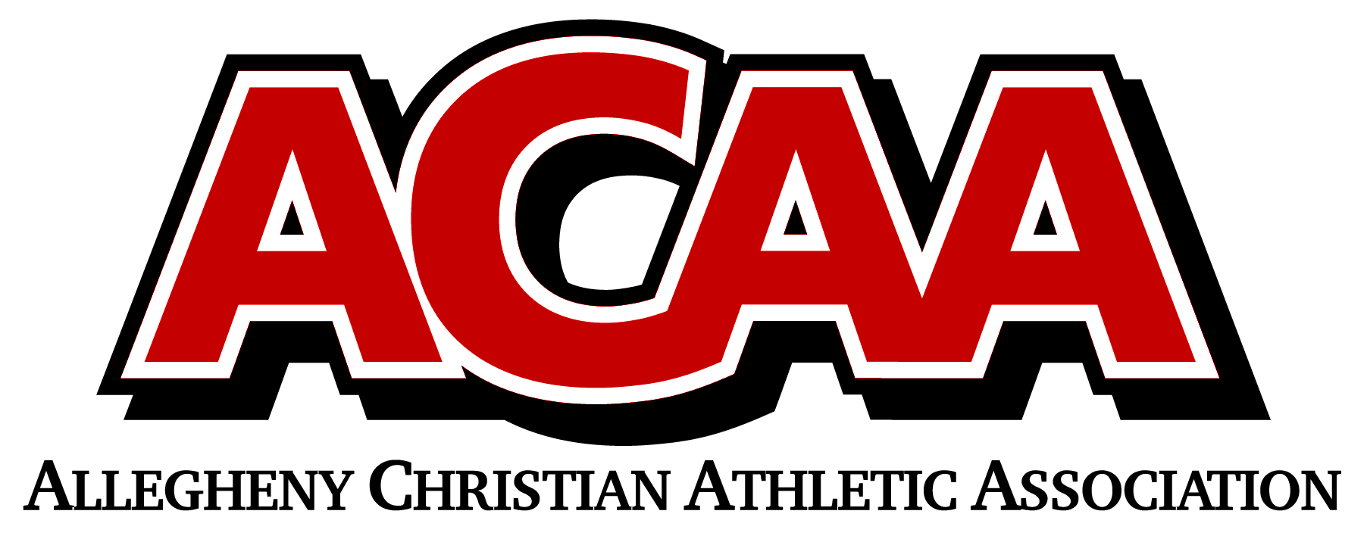

DIVISION ALIGNMENT 2021-2022

SOCCER
EASTERN DIVISION
# 1E | Columbia County Christian School
# 2E | Meadowbrook Christian School
# 3E | Belleville Mennonite School
# 4E | Northumberland Christian School
# 5E | BYE
# 6E | Walnut Street Christian School
# 7E | Grace Prep High School
# 8E | Juniata Christian School

WESTERN DIVISION
# 1W | Blair County Christian School
# 2W | Centre County Christian Academy
# 3W | Johnstown Christian School
# 4W | DuBois Christian Schools
# 5W | Great Commission Schools
# 6W | Huntington Christian Academy
# 7W | Cambria County Christian School
# 8W | Calvary Christian Academy

